PES UNIVERSITY, BANGALORE
Department of Computer Science and Engineering

Software Architecture and Design Specification
for
Vehicle Service & Maintenance
Management System

Document Item | Details
Version | 1.4
Status | Final Submission
Date | 31-Oct-2026
Course | Software Engineering

Prepared by
Priya K L - PES1UG24CS600
Prajwal S J - PES1UG24CS594
Harshith S - PES1UG24CS574
Basavaraj Mruthyunjaya Mudakammanavar - PES1UG24CS561

Revision History
Name | Date | Reason for Changes | Version
Project Team | 01-Oct-2026 | Initial SRS baseline used for architecture and design | 1.0
Project Team | 06-Oct-2026 | SAD prepared for final submission | 1.1
Project Team | 28-Oct-2026 | Finalize technology stack and project setup | 1.2
Project Team | 31-Oct-2026 | Document customer self-registration, profile linking, protected staff-role administration and authentication API behavior | 1.3
Project Team | 31-Oct-2026 | Design and integrate the Administrator User Management screen for staff accounts | 1.4

Table of Contents
1. Introduction ........................................................................................................................................... 1 1.1 Purpose ............................................................................................................................................... 1
1.2 Scope .................................................................................................................................................. 1
1.3 Audience ............................................................................................................................................. 1
1.4 Definitions ........................................................................................................................................... 1
2. Document Overview 4
2.2 Related Documents 4
3. Architecture 4
3.1 Architecture Goals and Constraints 4
3.2 Stakeholders and Concerns 4
3.3 Component Diagram 5
3.4 Component Descriptions 5
3.5 Chosen Architecture Pattern and Rationale 6
3.6 Technology Stack & Data Stores 6
3.7 Risks & Mitigations 6
3.8 Traceability to Requirements 7
3.9 Security Architecture 7
4. Design 7
4.1 Design Overview 7
4.2 UML Sequence Diagrams 7
4.2.1 Create, Review and Validate Service Request 7
4.2.2 Assign Work, Perform Service and Complete Request 8
4.3 API Design 9
4.4 Error Handling, Logging & Monitoring 9
4.5 UX Design 9
4.6 Open Issues & Next Steps 10
5. Appendices 10
5.1 Glossary 10
5.2 References 10

2.1 How to Use This Document ................................................................................................................... 2
5.3 Tools ................................................................................................................................................. 11

- Introduction
  - Purpose
This Software Architecture and Design Specification (SAD) defines the architecture and detailed design of the
Vehicle Service & Maintenance Management System (VSMMS). It translates the approved Software Requirements Specification (SRS) into an implementable architecture, component structure, system interactions, interfaces, security controls and design decisions.
  - Scope
The document covers release 1.0 architecture and design for customer and vehicle registration, service-request intake and validation, service work assignment, service execution and recording, service status and history, search, and user/access administration.
  - Audience
Developers, architects, testers, project managers, UI/UX designers, service-centre stakeholders and course evaluators.
  - Definitions
Definitions follow the SRS glossary, including Functional Requirement (FR), Non-Functional Requirement (NFR), Application Programming Interface (API), Role-Based Access Control (RBAC), Representational State Transfer (REST), Unified Modeling Language (UML), and Vehicle Service & Maintenance Management System (VSMMS).

2. Document Overview
2.1 How to Use This Document
Section 3 describes the architecture, components, architecture pattern, technology decisions, risks, traceability and security architecture. Section 4 describes detailed design, sequence diagrams, API interfaces, error handling, logging, monitoring and user experience. Section 5 provides supporting glossary, references and tools.

2.2 Related Documents
Document | Purpose
Software Requirements Specification (SRS), Version 1.3 | Defines functional/non-functional requirements, analysis models, field layouts and traceability; revised 31-Oct-2026.
Software Test Plan | Defines testing approach, security validation, test cases and requirement traceability.
UML Analysis Models | Provides the use-case, activity and entity-relationship models used as inputs to design.

3. Architecture

3.1 Architecture Goals and Constraints
- Separate presentation, application/business and data responsibilities.
- Provide modular components that can be developed and tested independently.
- Support the complete service-centre workflow.
- Enforce role-based access and protect customer/service data.
- Maintain data consistency and integrity.
- Support the SRS performance target.
Key constraints from the SRS:
- Browser-based application.
- HTTPS with TLS 1.2 or higher.
- Relational database with transaction support.
- Modular and separately testable design.
- English-only release 1.0 with texts externalised for future translation.
- Small student team and one academic term.

3.2 Stakeholders and Concerns
Stakeholder | Main Concern
Customer / Vehicle Owner | Easy requests and visibility of status/history.
Service Advisor / Service Staff | Fast registration, review, validation, assignment and status management.
Service Technician | Clear assigned work and reliable service recording.
Administrator | Secure user, role and configuration management.
Development Team | Modularity, maintainability, testability and clear interfaces.
Test / QA Team | Traceability and verifiable system behaviour.

3.3 Component Diagram
The component diagram uses the logical components defined in SRS Section 2.1.
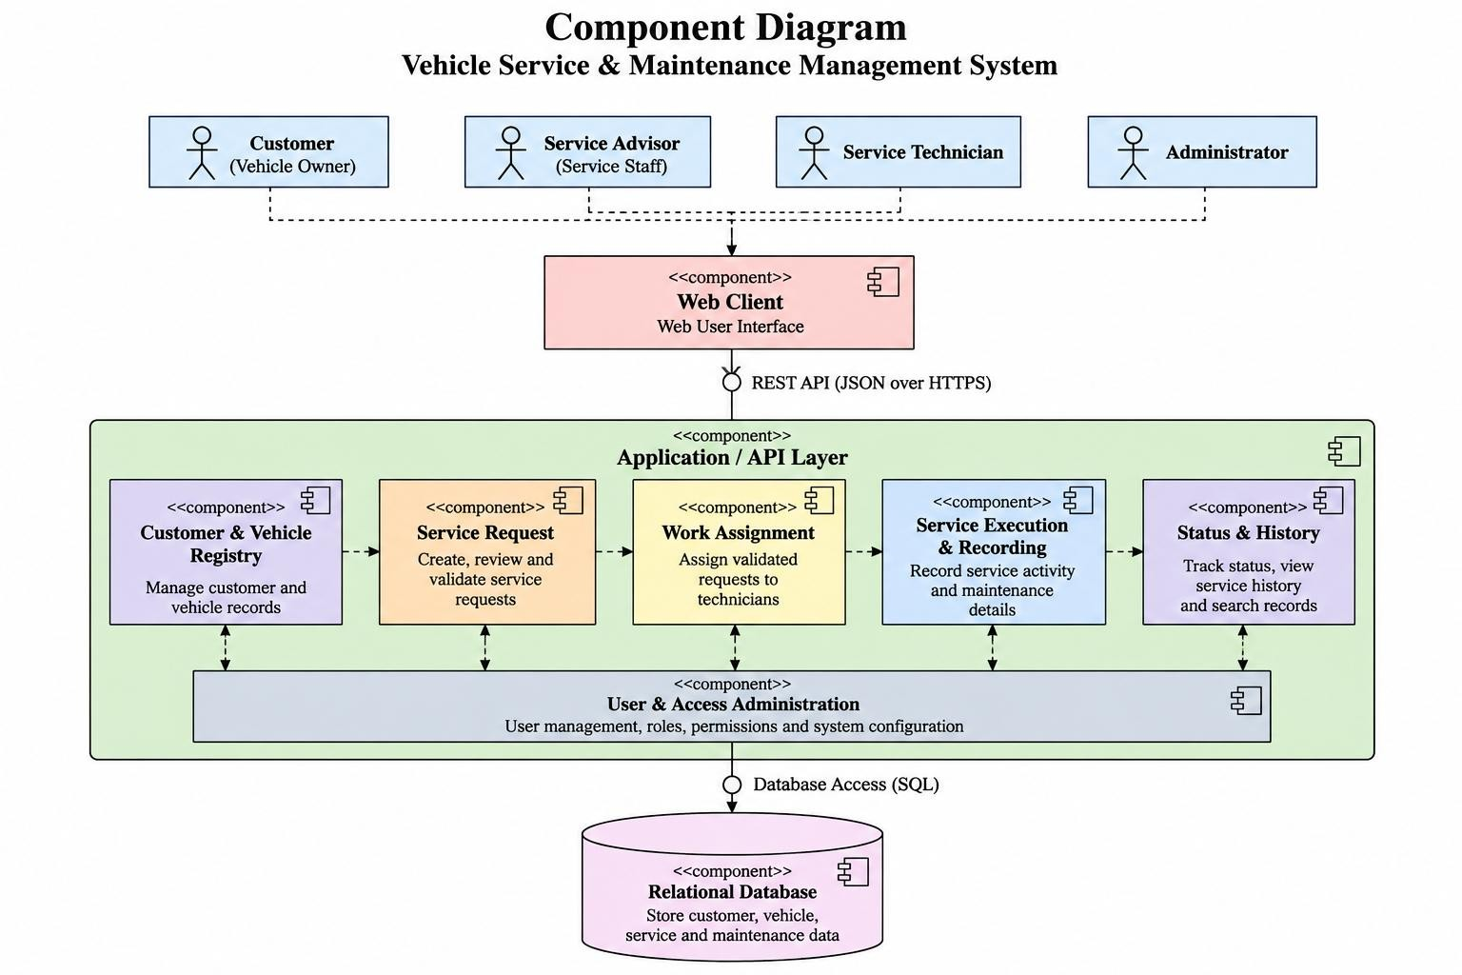

Figure 3-1: UML-style Component Diagram
The Web Client is used by all system users. It communicates with the application through the REST-style API. Application components implement business functions and access the relational database through database access services.

3.4 Component Descriptions
Component | Description | Requirement
Web Client | Responsive browser interface for all users. | FR-001 to FR-006
Customer & Vehicle Registry | Registers and maintains customer and vehicle records. | FR-001
Service Request | Creates, reviews and validates service requests. | FR-002
Work Assignment | Assigns validated requests to technicians and supports assigned-work viewing. | FR-003
Service Execution & Recording | Records service activity, maintenance details and completion information. | FR-004
Status & History | Tracks status, service history and record search. | FR-005
User & Access Administration | Manages accounts and roles. Public registration creates Customer accounts only; Administrators use the User Management screen and protected API to create staff/admin accounts, assign roles, update accounts, reset passwords and deactivate/reactivate users. | FR-006
Relational Database | Persistent store for customers, vehicles, requests, activities, maintenance records and users. | FR-001 to FR-006

3.5 Chosen Architecture Pattern and Rationale
The chosen architecture pattern for the design is Layered Architecture. This is a design decision for the SAD; the SRS does not explicitly name the pattern.
Layer | Responsibility
Presentation Layer | Responsive Web Client and user interaction.
Application / Business Layer | Validation, assignment, service execution, status/history and access-control logic.
Data Access Layer | Controlled database operations, parameterised SQL and transaction handling.
Data Layer | Relational database for persistent records.

The layered approach is suitable because it separates responsibilities and supports maintainability, testability and the SRS requirement for modular, separately testable modules.

3.6 Technology Stack & Data Stores
Area | Decision / Status
Client | Responsive web application built with React and TypeScript
Communication | REST-style API over HTTPS
Data format | JSON / UTF-8
Web security | HTTPS using TLS 1.2 or higher; TLS configured at the deployment proxy or hosting platform
Server | Node.js 24 LTS on a Linux-based server or container platform
Database | SQLite 3, embedded relational database stored in a local database file
Database access | better-sqlite3 Node.js driver, using prepared SQL statements and transactions
Password hashing | bcrypt with a cost factor of 12
Frontend framework | React with TypeScript; Vite for development and production builds
Backend framework | Express with TypeScript
Database product/version | SQLite 3; better-sqlite3 driver version 12.11.1 is locked in the current project

.

3.7 Risks & Mitigations
Risk | Impact | Mitigation
Unauthorized access | Data exposure or modification | Authentication, RBAC and authorization checks.
Invalid request | Incorrect work assignment | Validate mandatory fields and vehicle registration.
Database failure | Loss of availability | Automated daily backups and controlled database operations.
Incorrect status | Incorrect information | Validate status transitions and timestamp changes.
Performance degradation | Workshop delays | Performance testing against the 50-user target.
Post-completion modification | Record integrity loss | Make completed entries read-only.
Incorrect role assignment | Unauthorized functions | Restrict role management to administrators.

3.8 Traceability to Requirements
Requirement | Architecture Component | Design Reference
FR-001 | Customer & Vehicle Registry | Sequence 1; customer/vehicle design
FR-002 | Service Request | Sequence 1; validation design
FR-003 | Work Assignment | Sequence 2; assignment design
FR-004 | Service Execution & Recording | Sequence 2; service recording design
FR-005 | Status & History | Sequence 2; status/history design
FR-006 | User & Access Administration | Security architecture; access-control design
NFR-001 | Web Client + Application + Database | Performance design/monitoring
NFR-002 | User & Access + Security + Database | Security architecture

These references are intended to replace the architecture/design TBD entries in the SRS Requirement Traceability Matrix during final document integration.

3.9 Security Architecture
Security Control | Design
Authentication | Staff sign in through the login endpoint. Public registration creates a Customer role only and offers no role selector; registration and login return bearer tokens for authenticated API calls.
Role-Based Access Control | Permissions are based on Customer, Service Advisor, Service Technician or Administrator. Public registration cannot grant a staff/Admin role.
Authorization | Protected operations are checked against the authenticated user's role.
Transport Security | Browser-server communication uses HTTPS with TLS 1.2 or higher.
Password Protection | Passwords are hashed with bcrypt (cost factor 12); plaintext passwords are not stored.
Audit Logging | Customer self-registration, successful authentication, administrative account changes, status changes and record edits are recorded with actor/target details and timestamps where applicable.
Data Integrity | Completed service activity and maintenance records are read-only.
Customer profile linking | Within a database transaction, link only an unlinked customer record whose email and normalized name match; reject mismatches/already-linked records; otherwise create a new profile. The submitted phone is not part of the current match rule.

4. Design

4.1 Design Overview
The detailed design translates the architecture into implementable interactions. The Web Client communicates with application components through a REST-style API using JSON. Application components enforce business rules and role permissions, while the data access layer performs controlled operations on the relational database.
- Create, review and validate a service request.
- Assign a validated request to a Service Technician.
- Perform service and record maintenance details.
- Complete a service request and update status/history.
- Control access according to user roles.

4.2 UML Sequence Diagrams

4.2.1 Create, Review and Validate Service Request
This sequence represents the FR-002 workflow from request creation through validation or rejection.
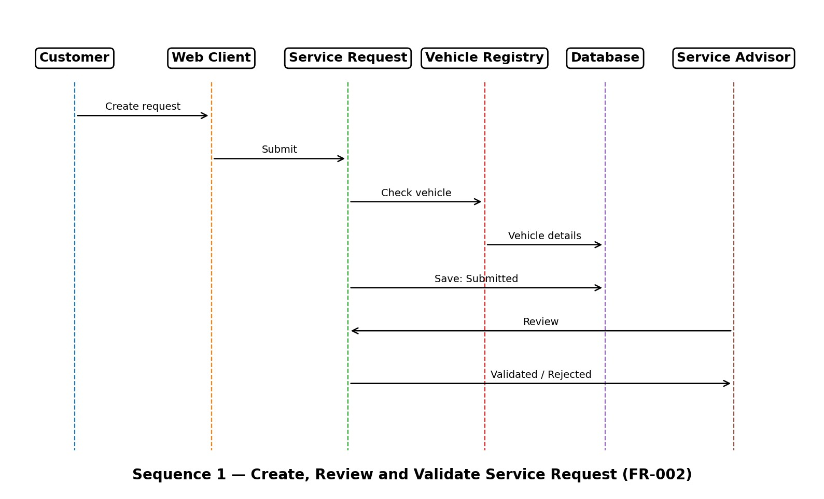
Figure 4-1: Sequence Diagram — Create, Review and Validate Service Request

4.2.2 Assign Work, Perform Service and Complete Request
This sequence covers FR-003 and FR-004, from assignment of a validated request through service execution and completion.
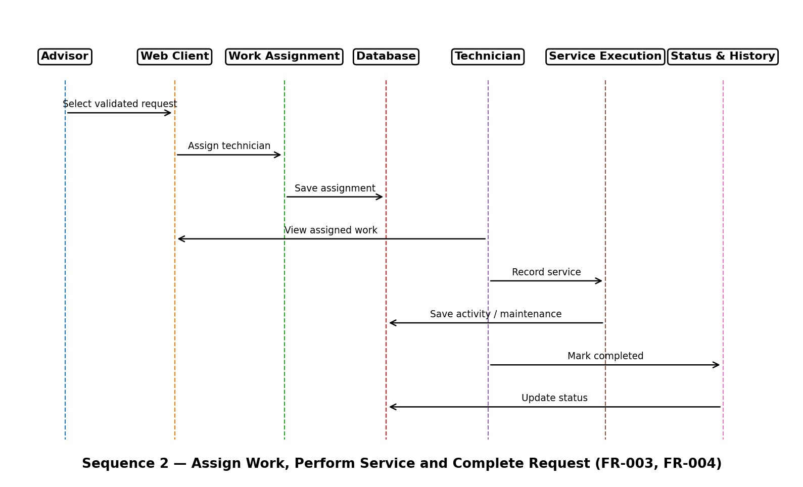
Figure 4-2: Sequence Diagram — Assign Work, Perform Service and Complete Request

4.3 API Design
The system exposes a REST-style API using JSON. Implemented authentication and account-management endpoints are listed below; service-work endpoints remain design references where marked proposed.
Method | Endpoint | Purpose
POST | /api/service-requests | Create service request.
GET | /api/service-requests/{id} | Retrieve service request.
PUT | /api/service-requests/{id}/status | Update status.
POST | /api/service-requests/{id}/assign | Assign technician.
POST | /api/service-requests/{id}/activities | Record service activity.
GET | /api/vehicles/{id}/history | Retrieve vehicle service history.
POST | /api/auth/register | Public customer registration. Creates a Customer login and profile, or links an unlinked profile by matching email and normalized name; returns a bearer token. Phone is collected but is not used for profile matching.
POST | /api/auth/login | Authenticate an active account; returns a one-hour bearer token.
GET | /api/admin/users | Administrator-only paginated user listing.
POST | /api/admin/users | Administrator-only account creation with explicit role assignment.
PATCH | /api/admin/users/{id} | Administrator-only account update, role change, activation/deactivation or password reset.

Example request:
{ "vehicleId": "V001", "serviceType": "Oil Change", "description": "Engine oil replacement" }
Example response:
{ "requestId": "SR001", "status": "Submitted" }

4.4 Error Handling, Logging & Monitoring
Condition | Expected Handling
Invalid login | Reject authentication and display a general authentication error.
Missing mandatory field | Display a field-level validation message.
Vehicle not registered | Reject request and explain validation failure.
Unauthorized operation | Reject operation and return access-denied response.
Request not found | Return a not-found response and clear message.
Database failure | Log technical error and display a general failure message.
Invalid status transition | Reject operation and preserve current valid status.

Logging should cover authentication/security events, status changes, record edits, administrative changes and application/database errors. Monitoring should cover application errors, API response time, database availability and performance-test results.

4.5 UX Design
The SRS requires a responsive interface from 360 px width, consistent Save/Cancel/Back/Help controls, inline error messages, keyboard navigation, sufficient colour contrast, text alternatives and WCAG 2.1 Level AA accessibility.
Screen | Users | Purpose
Sign-up / Log-in | Customer registration; all roles sign in | Public signup creates a Customer account only; signup links matching unlinked profile or creates a profile. Staff accounts are provisioned by an Administrator through the protected API; a browser user-management page is not implemented yet.
Customer & Vehicle Registration | Service Advisor | Register/maintain records.
My Vehicles | Customer | View vehicles.
Create Service Request | Customer, Advisor | Submit request.
Review Requests | Advisor | Review/validate/reject.
Assign Service Work | Advisor | Assign validated work.
My Assigned Work | Technician | View assigned requests.
Service Execution / Recording | Technician | Record service/maintenance.
Service Status & History | Customer, Advisor | View status/history.
Search Records | Advisor, Administrator | Search records.
User & Access Management | Administrator | Administrator-only screen to create and manage staff roles, reset passwords and deactivate/reactivate accounts; Customer registration remains public and Customer-only.

4.6 Open Issues & Next Steps
- Finalize API endpoint naming.
- Finalize deployment/hosting configuration.
- Validate the Administrator User Management screen and responsive layouts against the final UI requirements.
- Update SRS RTM with final architecture/design references.
- Execute tests and record Actual Result and Pass/Fail in the Test Plan.

5. Appendices

5.1 Glossary
Term | Definition
API | Application Programming Interface.
FR | Functional Requirement.
NFR | Non-Functional Requirement.
RBAC | Role-Based Access Control.
REST | Representational State Transfer.
JSON | JavaScript Object Notation.
SQL | Structured Query Language.
TLS | Transport Layer Security.
UML | Unified Modeling Language.
UX | User Experience.
SAD | Software Architecture and Design Specification.
SRS | Software Requirements Specification.
VSMMS | Vehicle Service & Maintenance Management System.
WCAG | Web Content Accessibility Guidelines.

5.2 References
- PES University, Department of Computer Science and Engineering, Software Requirements Specification for Vehicle Service & Maintenance Management System, Version 1.3, revised 31-Oct-2026.
- PES University, Software Architecture and Design Specification template/sample, Software Engineering course material.
- PES University, Software Test Plan and test cases, Software Engineering course material.
- ISO/IEC/IEEE 29148:2018, Systems and software engineering — Life cycle processes — Requirements engineering.
- IEEE Std 830-1998, Recommended Practice for Software Requirements Specifications.
- Object Management Group, Unified Modeling Language (UML) Specification, Version 2.5.1.
- OWASP Application Security Verification Standard (ASVS), Version 4.0.3.
- Digital Personal Data Protection Act, 2023.
5.3 Tools
Tool / Technology | Purpose
GitHub | Version control and team collaboration.
Microsoft Word | SAD preparation and final submission.
UML diagramming tool | Component and sequence diagrams.
Visual Studio Code | Software development and source-code editing.
Relational database tool | Database development and testing.

End of Software Architecture and Design Specification

